**Educational Organisation**

**Using**

**Service Now**



**Problem Statement:**

To create a centralized and automated platform using Service Now to streamline operations, manage resources, and enhance service delivery in an educational organization.

**Objective:**

The Educational Management System is a comprehensive platform designed to streamline administrative tasks within educational institutions. It facilitates efficient management of student and teacher data, simplifies the admission process, and provides tools for monitoring student progress.

***Milestone 1: Setting up Service Now Instance***

* Sign up for a developer account on the ServiceNow Developer site <https://developer.servicenow.com>
* Once logged in, navigate to the “Personal Developer Instance” section.

Click on “Request Instance”

To create a new Service

Now instance.

* Fill out the required information and submit the request.
* You’ll receive an email with the instance details once it’s ready.
* Log in to your ServiceNow instance using the provided credentials.
* Now you will navigate to the ServiceNow.

***Milestone 2: Creating a Update Set***

* Click on All >> Local update sets .

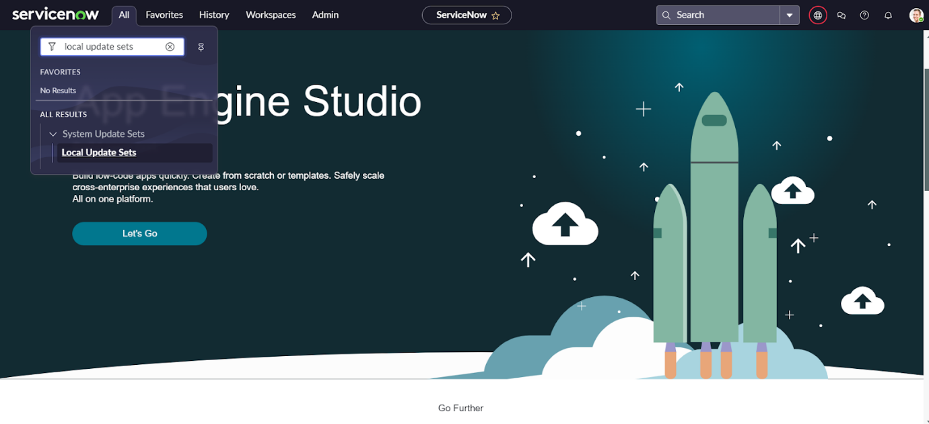

* Click on new

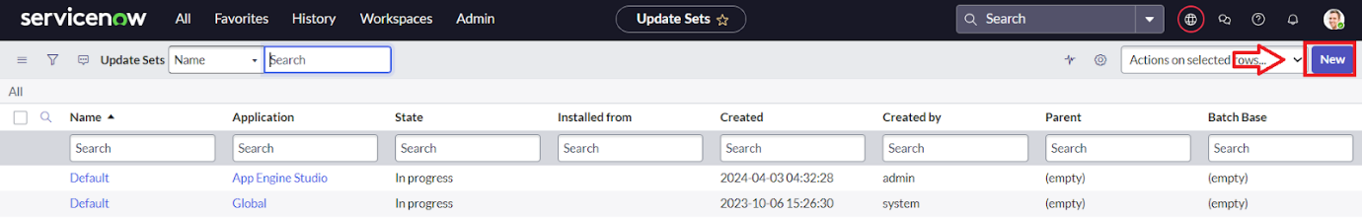

* Enter the Details Name: Educational Organisation >> Click on Submit and make Current.

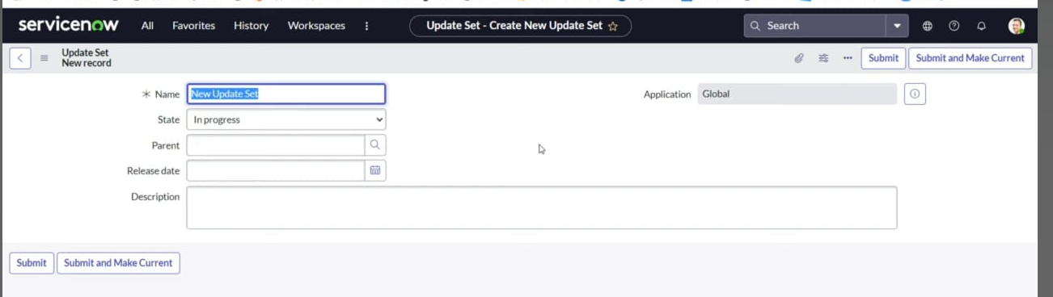

***Milestone 3: Creating a Table***

**Activity 1 : Creating Salesforce table**

* All >> Tables.

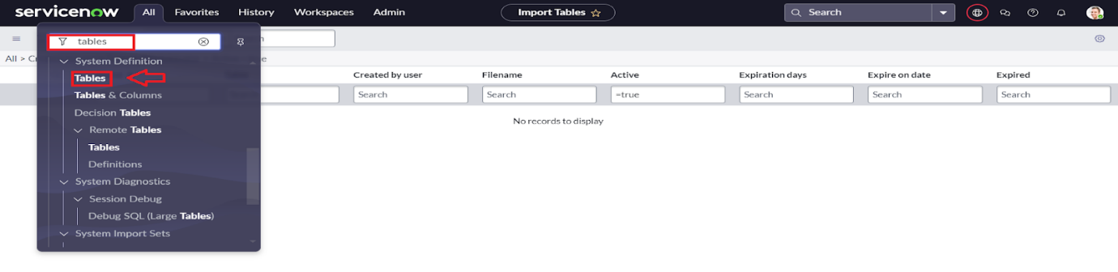

* Click on new

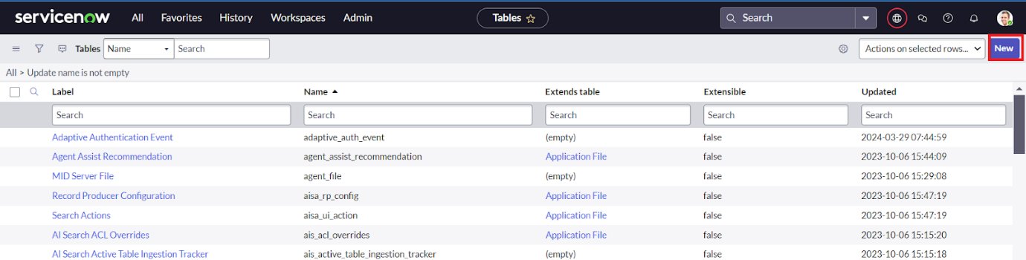

* Enter the Label(Anything you want): Salesforce >> Click on Name it will Automatically generate Api name.

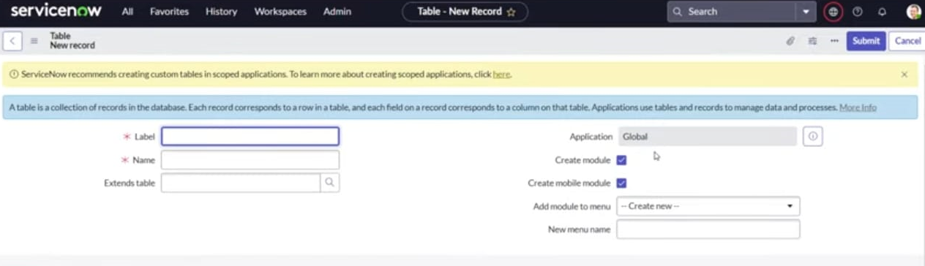

* Create columns as given below,Double Click on Column label and Enter the Column labels and click on the tick mark >> Give Type as given .

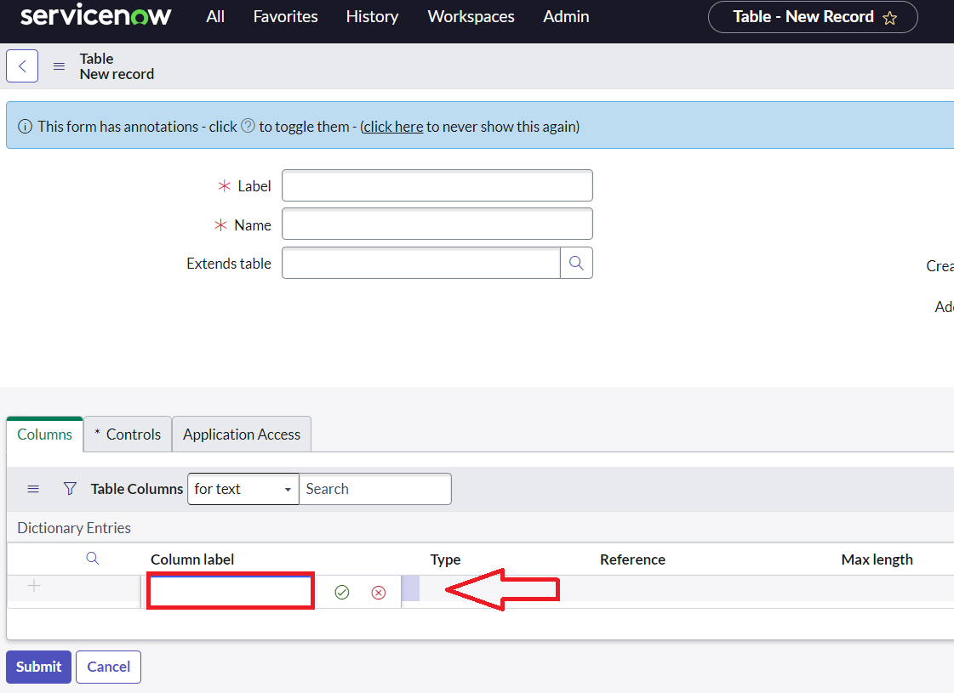

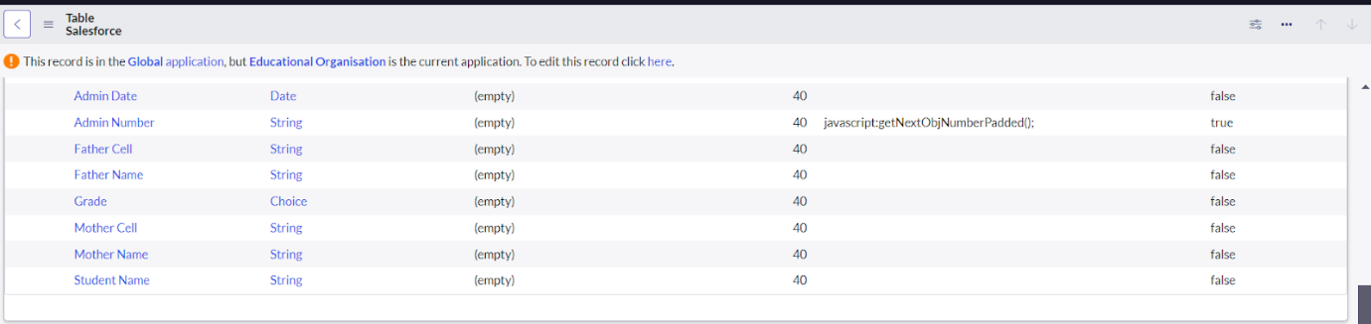

* For “Admin Number” Give Display as True and right click on the toggle bar on top >> save.

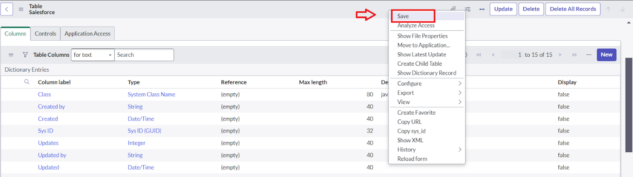

* Click on controls >> Enable Extensible.

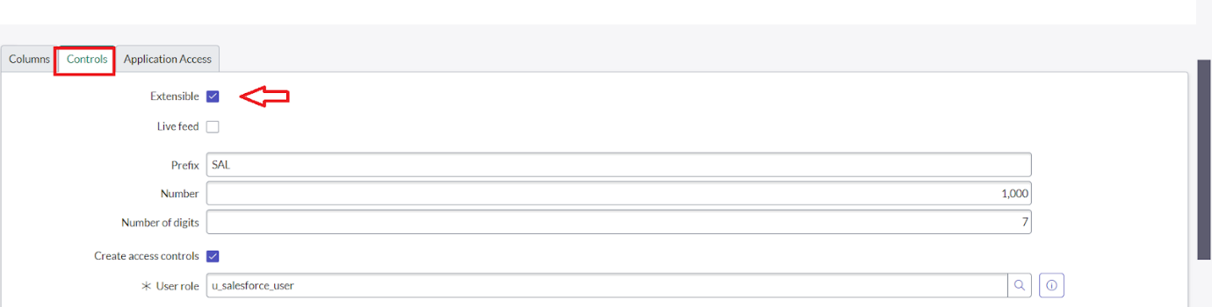

* Click on “Admin Number” column, In Related Links Click on Advanced View >> Default View (Enable Use dynamic default) >> select Get Next Padded Number in Dynamic default value >> Update .

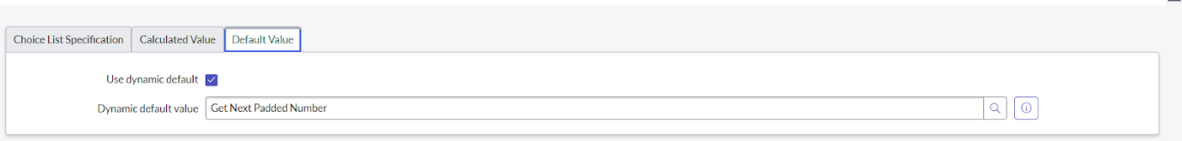

* Click on “Grade” Column >> Click on Choices and give Label,Value and Sequence as given below.

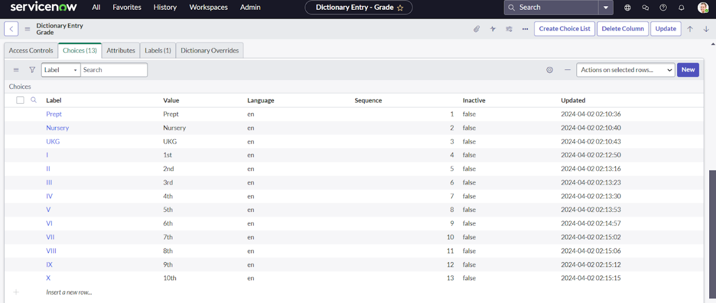

**Activity 2: Creating Admission Table**

* Create an Admission Table with Columns given.
* Select Extends Table >> Salesforce and also Select Add module to menu >> Salesforce.
* Create Fields as shown

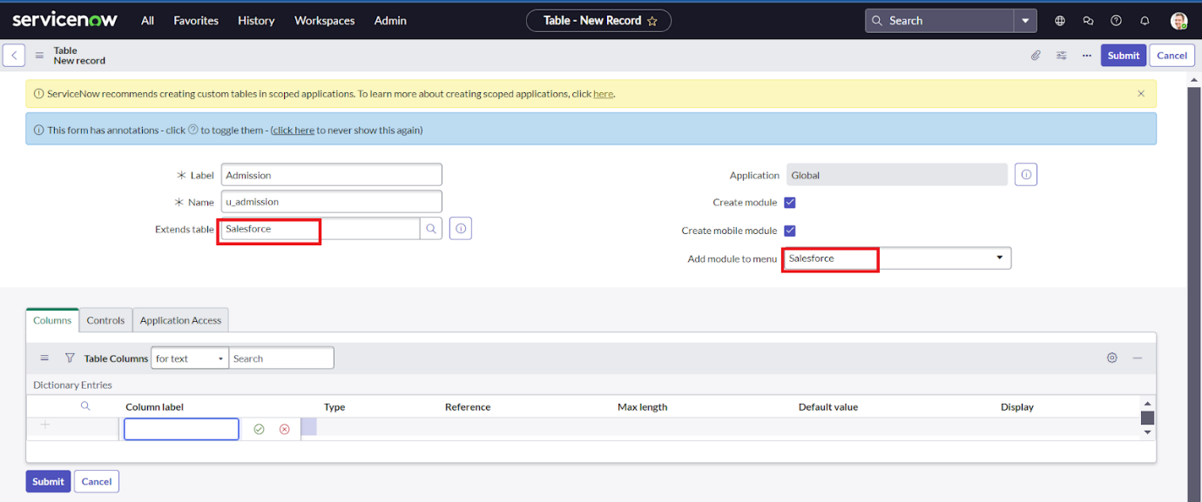

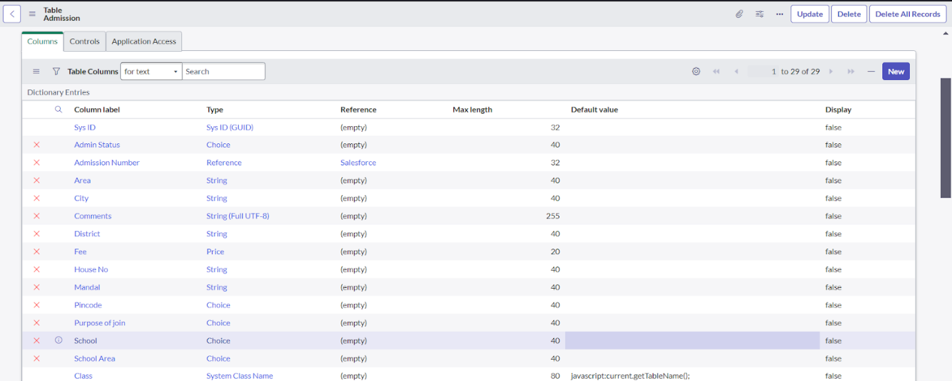

* Create choice for Admin Status as:

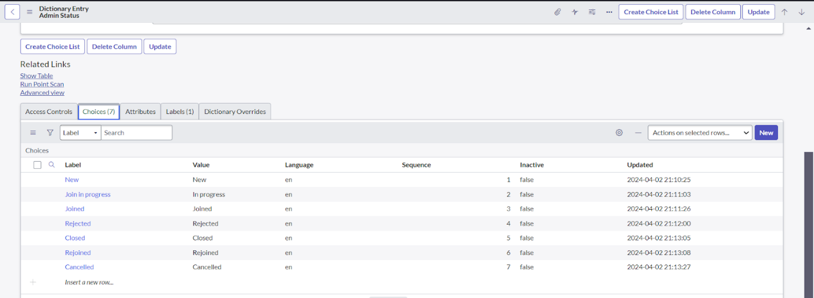

* Create choice for Pincode as:
* Create choice for Purpose of Join as:
* Create choice for School as:
* Create choice for School Area as:

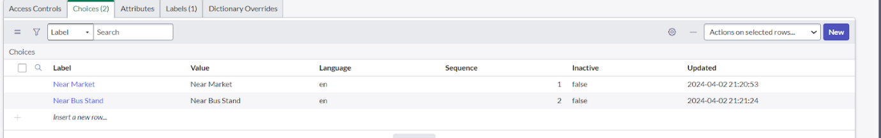

**Activity 3:** **Creating Student Progress Table**

* Create a Student Progress Table with Columns given.
* Select Add module to menu >> Salesforce.
* Create Fields as shown:

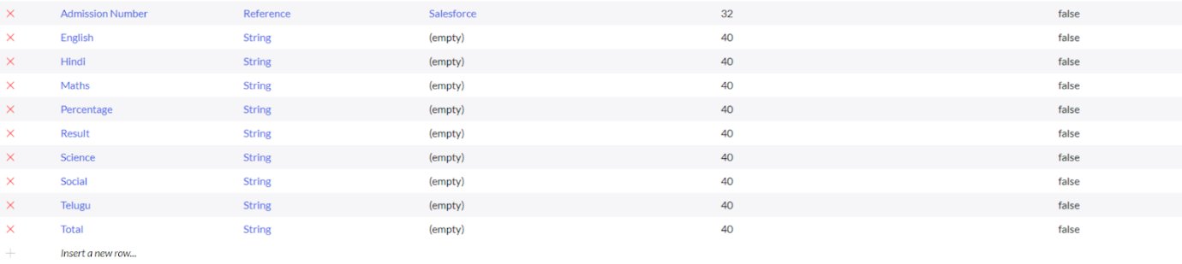

***Milestone 4: Form Layout***

**Activity 1: Configuring Table form for Student Progress Tables**

* In the Student Progress Table Page , Click on Layout form .

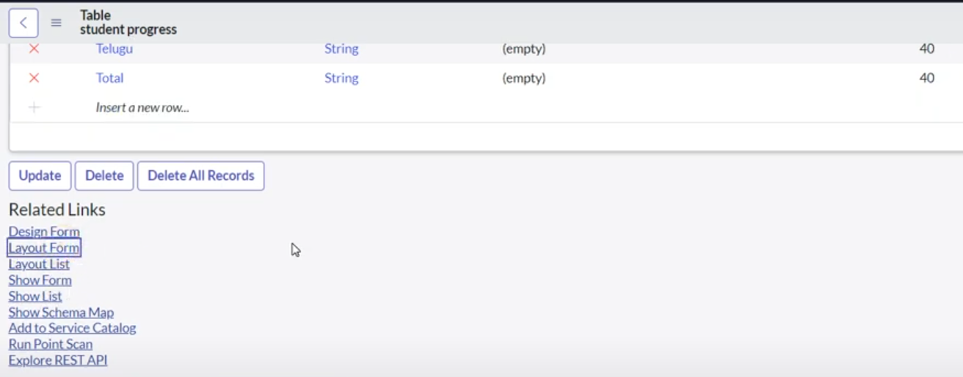

* Click on Admission Number [+] .

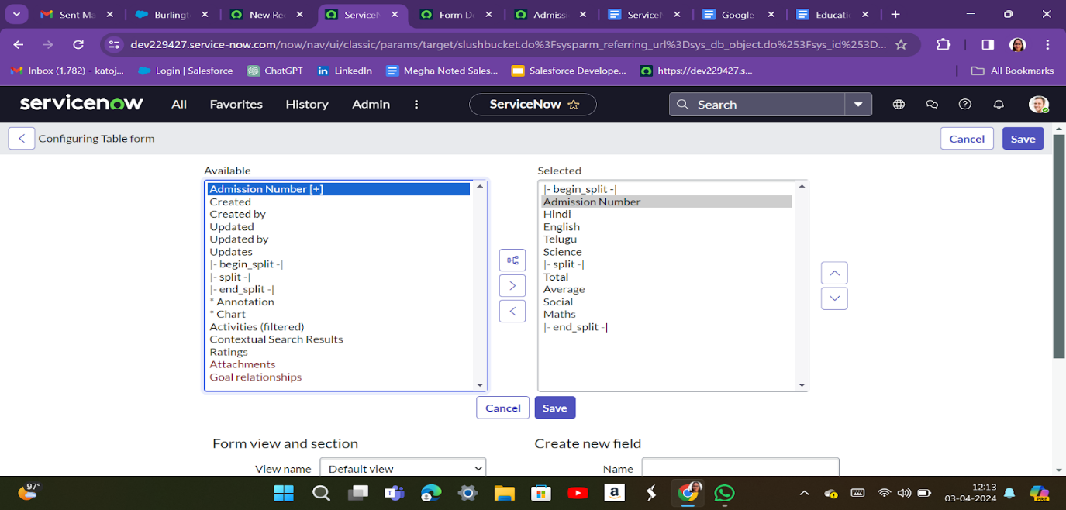

* Select below Admission Number fields in Available side and send it to selected side as below >> save.

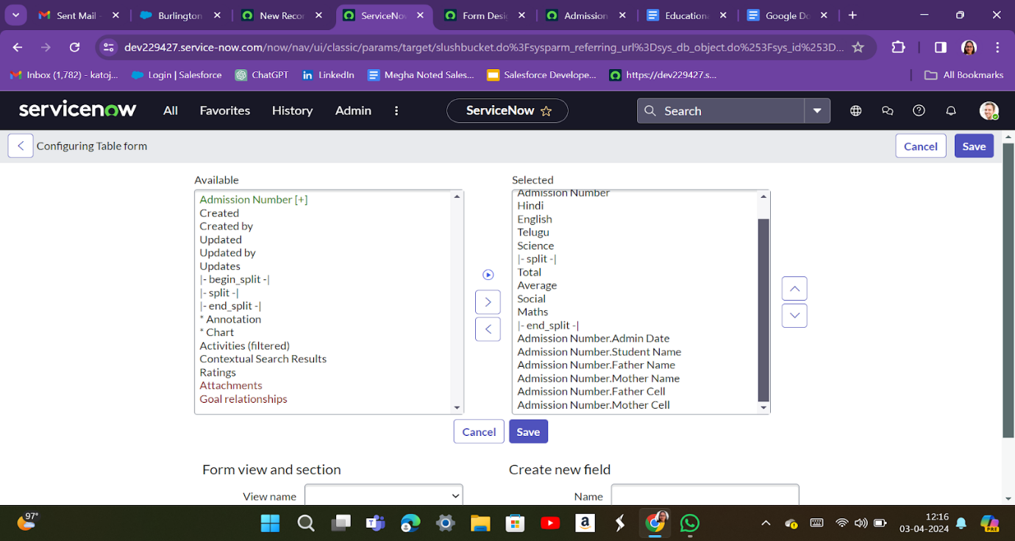

***Milestone 5: Form Design***

**Activity 1: Creating Form Design for Salesforce Table**

* All >> System Definition >> Tables .
* In Label Search for Salesforce and open .

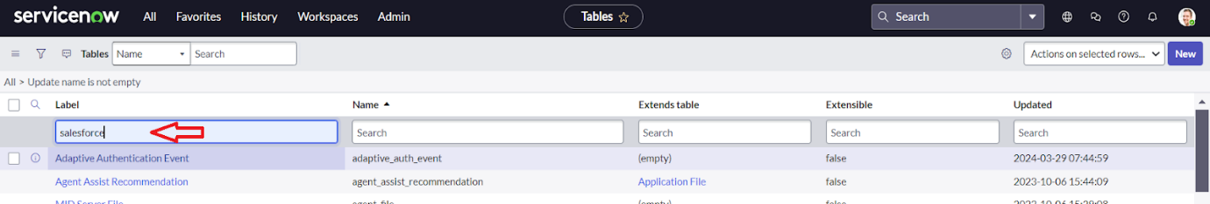

* Right Click on top Toggle >> Configure >> Form Design.

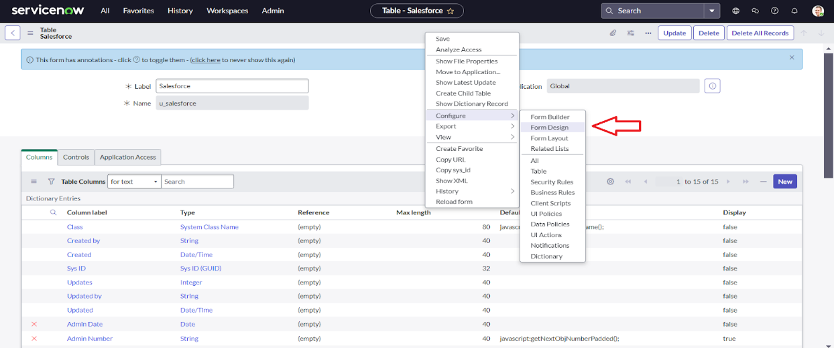

* In drop down select Salesforce(u_salesforce).

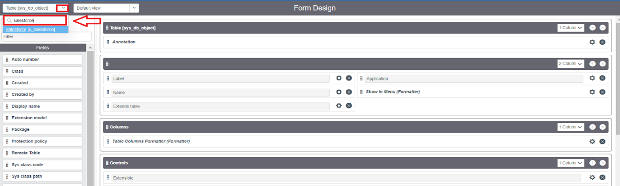

* Drag and drop the fields to the left side as below.

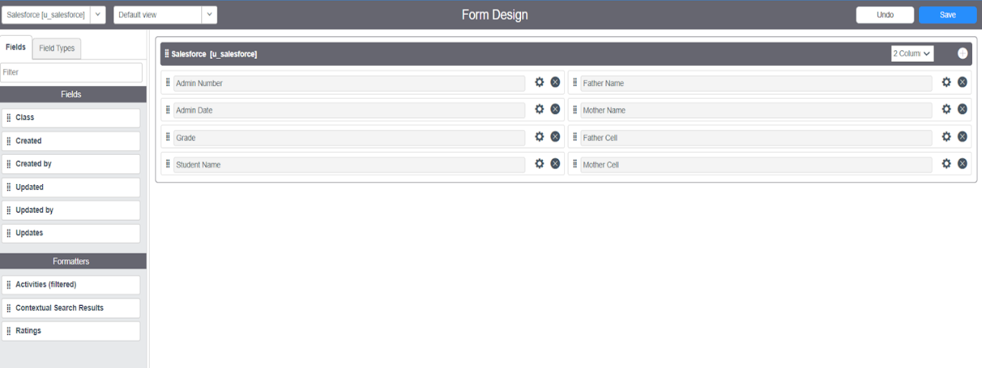

* Save.

**Activity 2: Creating Form Design for Admission Table**

Follow the same steps as Activity1,Configure the fields as below and Save.

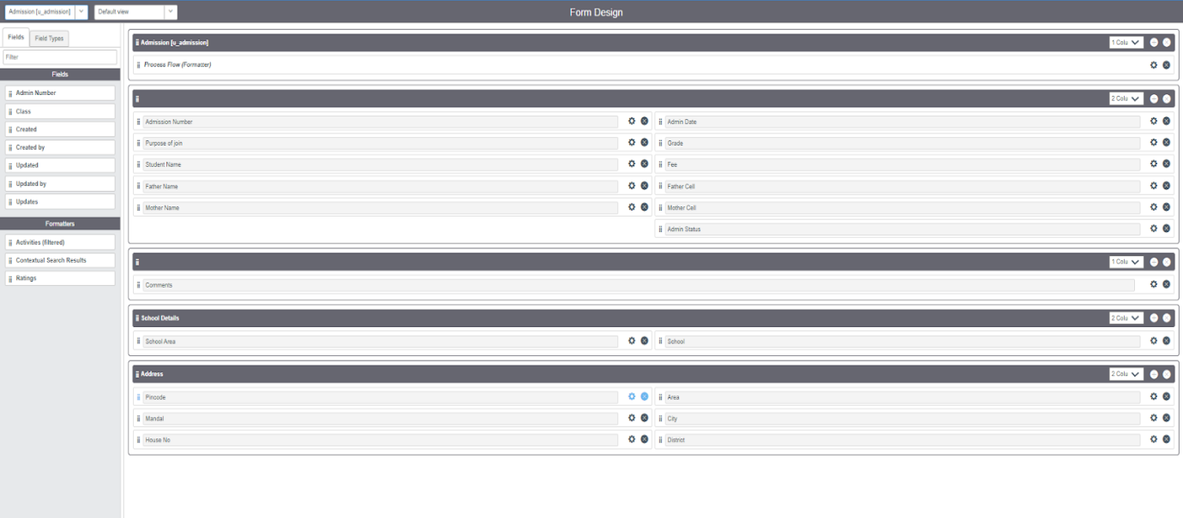

**Activity 3: Creating Form Design for Student progress Table**

Follow the same steps as Activity1,Configure the fields as below and Save.

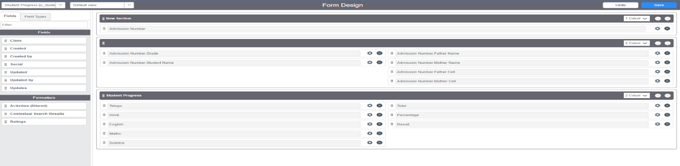

***Milestone 6: Number Maintenance***

**Activity 1: Creating Number Maintenance for Admin Number**

* All >> Number Maintenance >> New

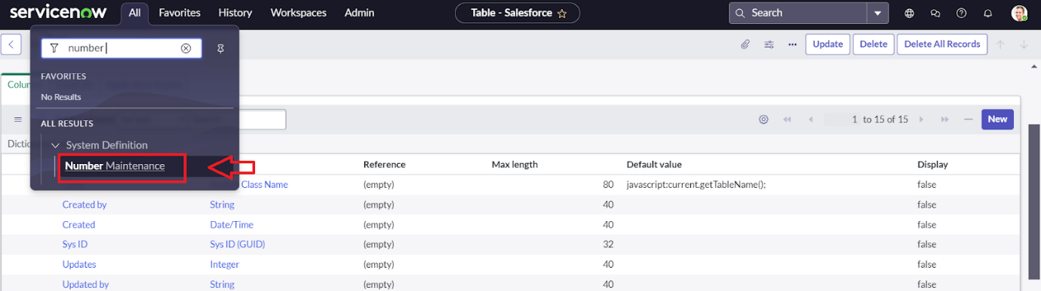

* Fill the details >> Submit.

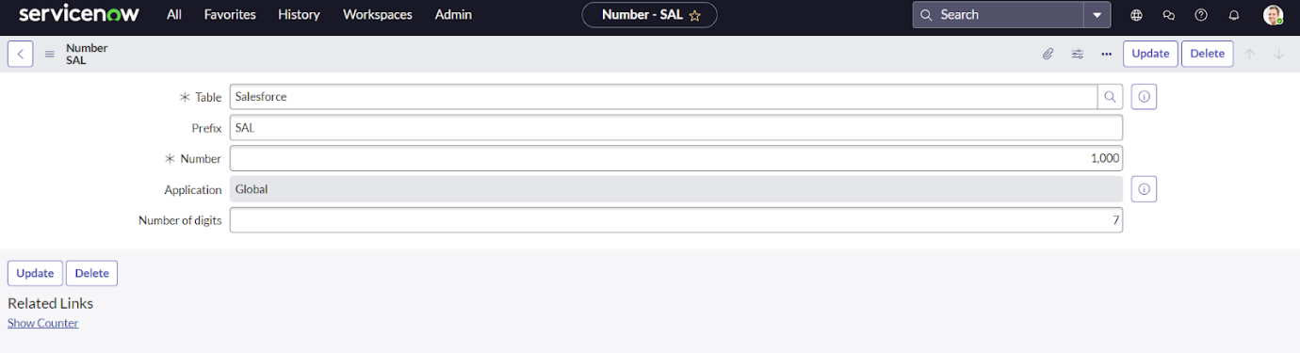

***Milestone 7: Process Flow***

**Activity 1: Creating Process Flow for Admission Table**

* All >> Process Flow>> New.
* Fill the Details as given Below

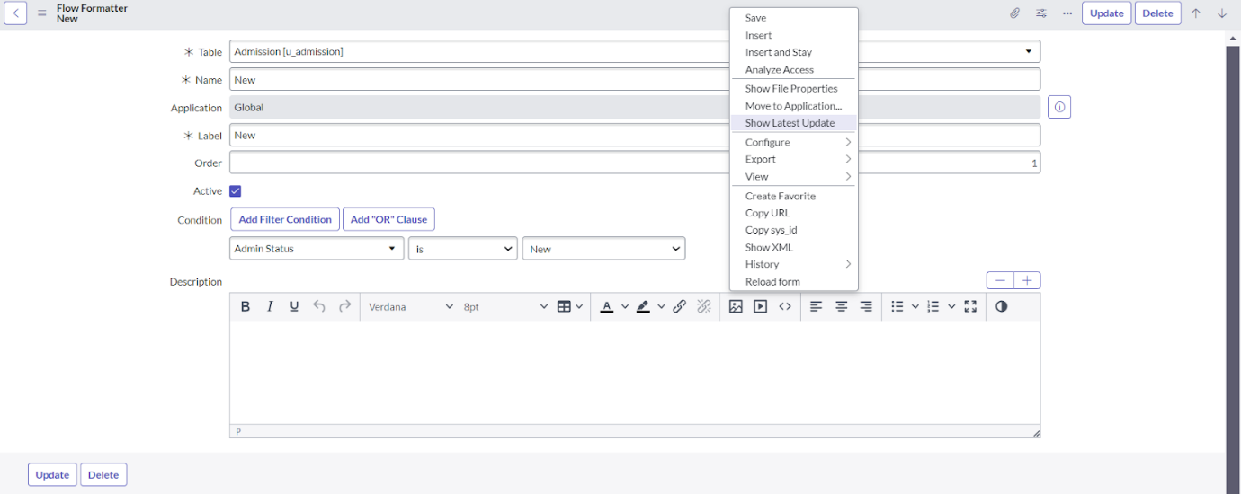

* Right Click on toggle and click on the save .
* Replace the Name and Label as below and click on Insert on stay.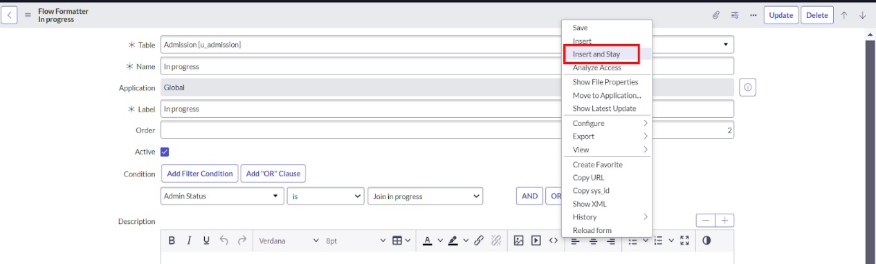
* Replace the Name and Label in order and click on Insert on stay.

Joined >> Rejected >> Rejoined >> Closed >> Cancelled.

* Order should be New >> InProgress >> Joined >> Rejected >> Rejoined >> Closed >> Cancelled.

***Milestone 8: Client Script***

**Activity 1: Creating “Auto populate” Client Scripts for Admission Table**

* All >> Client Scripts >> New.
* Fill the Details as given.

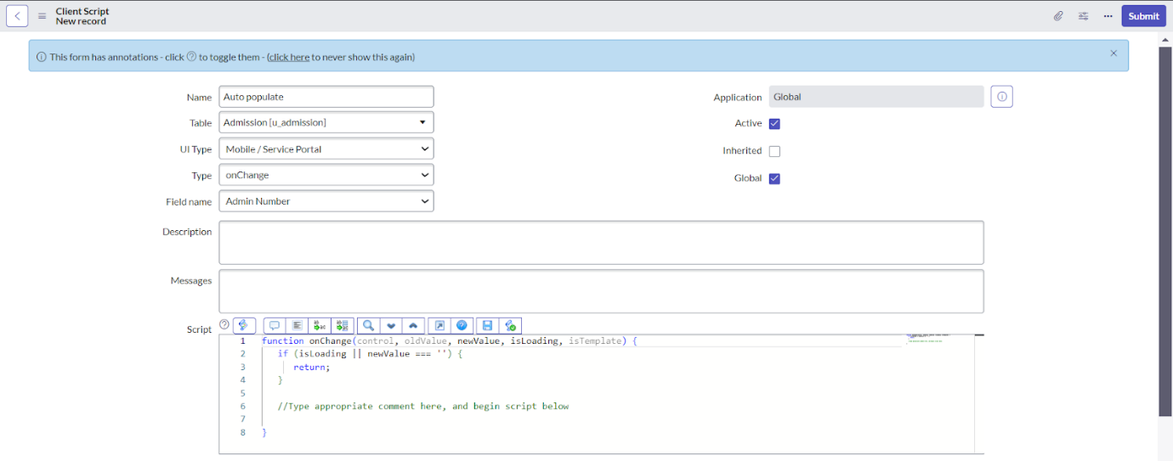

* Write the Code as below, Enable Isolate script and Save.

*function onChange(control, oldValue, newValue, isLoading, isTemplate)*

*{*

*if (isLoading || newValue === '') {*

*return;*

*}*

*//Type appropriate comment here, and begin script below*

*var a = g_form.getReference('u_admission_number');*

*g_form.setValue('u_admin_date',a.u_admin_date);*

*g_form.setValue('u_grade',a.u_grade);*

*g_form.setValue('u_student_name',a.u_student_name);*

*g_form.setValue('u_father_name',a.u_father_name);*

*g_form.setValue('u_mother_name',a.u_mother_name);*

*g_form.setValue('u_father_cell',a.u_father_cell);*

*g_form.setValue('u_mother_cell',a.u_mother_cell);*

*g_form.setDisabled('u_admin_date',a.u_admin_date);*

*g_form.setDisabled('u_grade',a.u_grade);*

*g_form.setDisabled('u_student_name',a.u_student_name);*

*g_form.setDisabled('u_father_name',a.u_father_name);*

*g_form.setDisabled('u_mother_name',a.u_mother_name);*

*g_form.setDisabled('u_father_cell',a.u_father_cell);*

*g_form.setDisabled('u_mother_cell',a.u_mother_cell);*

*}*

**Note: Make sure the Field names should be the same as you created .**

**Activity 2: Creating “Pincode Update” Client Scripts for Admission Table**

* Fill the Details as given.

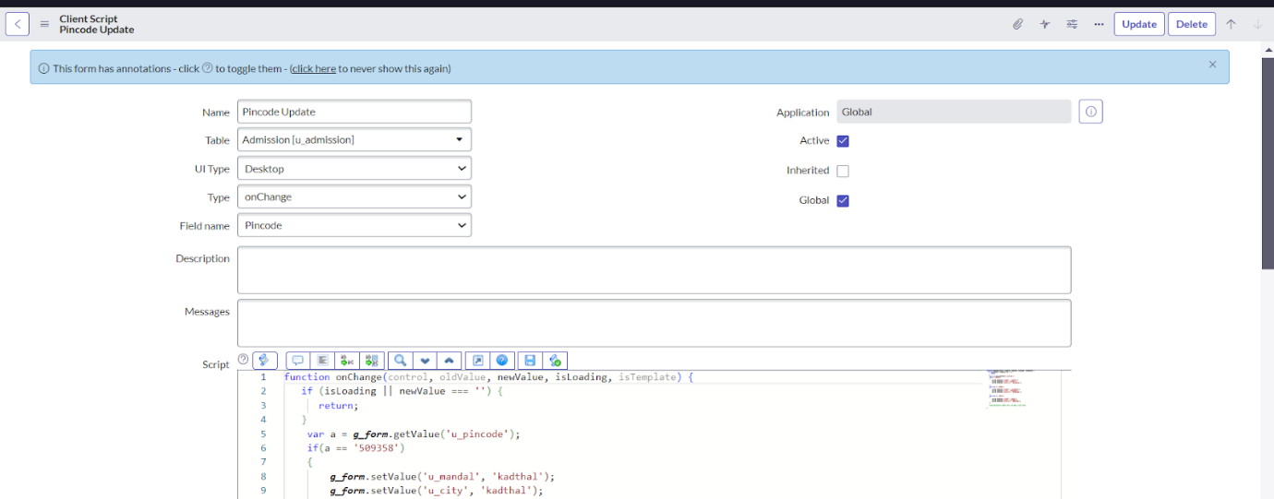

* Write the Code as below, Enable Isolate script and Save.

*function onChange(control, oldValue, newValue, isLoading, isTemplate)*

*{*

*if (isLoading || newValue === '') {*

*return;*

*}*

*var a = g_form.getValue('u_pincode');*

*if(a == '509358')*

*{*

*g_form.setValue('u_mandal', 'kadthal');*

*g_form.setValue('u_city', 'kadthal');*

*g_form.setValue('u_district', 'RangaReddy');*

*}*

*else if(a == '500081')*

*{*

*g_form.setValue('u_mandal', 'karmanghat');*

*g_form.setValue('u_city', 'karmanghat');*

*g_form.setValue('u_district', 'RangaReddy');*

*}*

*else if(a == '500079')*

*{*

*g_form.setValue('u_mandal', 'Abids');*

*g_form.setValue('u_city', 'AsifNagar');*

*g_form.setValue('u_district', 'Hyderabad');*

*}*

*//Type appropriate comment here, and begin script below*

*}*

**Activity 3: Creating “Disable Fields” Client Scripts for Student progress Table**

* Fill the Details as given.

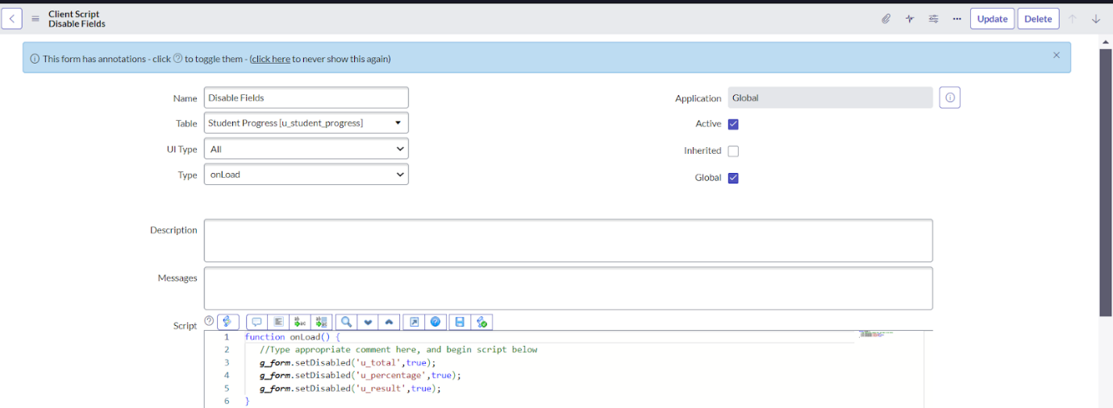

* Write the Code as below, Enable Isolate script and Save.

*function onLoad() {*

*//Type appropriate comment here, and begin script below*

*g_form.setDisabled('u_total',true);*

*g_form.setDisabled('u_percentage',true);*

*g_form.setDisabled('u_result',true);*

*}*

**Activity 4: Creating “Total Update” Client Scripts for Student progress Table**

* Fill the Details as given.

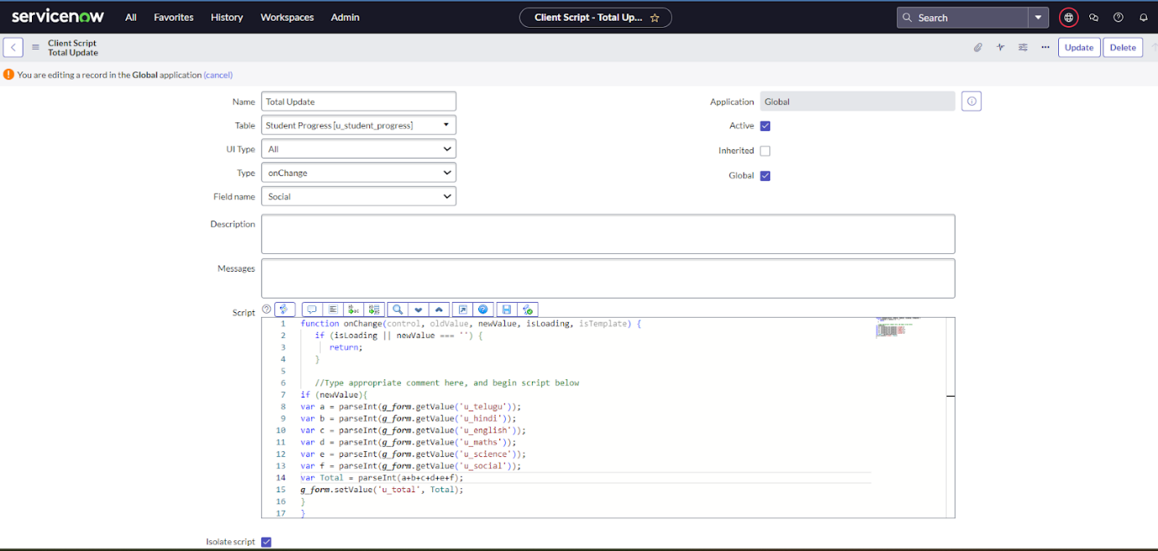

* Write the Code as below, Enable Isolate script and Save.

*function onChange(control, oldValue, newValue, isLoading, isTemplate) {*

*if (isLoading || newValue === '') {*

*return;*

*}*

*//Type appropriate comment here, and begin script below*

*if (newValue){*

*var a = parseInt(g_form.getValue('u_telugu'));*

*var b = parseInt(g_form.getValue('u_hindi'));*

*var c = parseInt(g_form.getValue('u_english'));*

*var d = parseInt(g_form.getValue('u_maths'));*

*var e = parseInt(g_form.getValue('u_science'));*

*var f = parseInt(g_form.getValue('u_social'));*

*var Total = parseInt(a+b+c+d+e+f);*

*g_form.setValue('u_total', Total);*

*}*

*}*

**Activity 5: Creating “Result” Client Scripts for Student progress Table**

* Fill the Details as given.

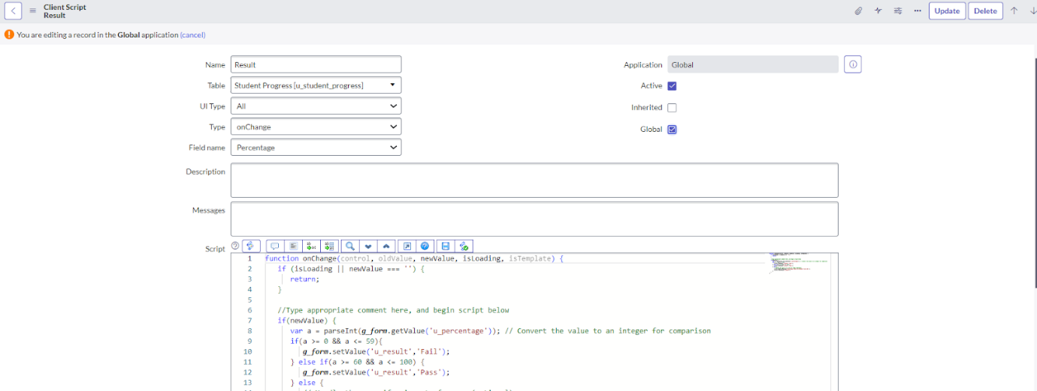

* Write the Code as below, Enable Isolate script and Save.

*function onChange(control, oldValue, newValue, isLoading, isTemplate) {*

*if (isLoading || newValue === '') {*

*return;*

*}*

*//Type appropriate comment here, and begin script below*

*if(newValue) {*

*var a = parseInt(g_form.getValue('u_percentage')); // Convert the value to an integer for comparison*

*if(a >= 0 && a <= 59){*

*g_form.setValue('u_result','Fail');*

*} else if(a >= 60 && a <= 100) {*

*g_form.setValue('u_result','Pass');*

*} else {*

*// Handle the case if a is out of range (optional)*

*g_form.addErrorMessage('Percentage should be between 0 and 100.');*

*g_form.clearValue('u_result');*

*}*

*}*

*}*

**Activity 6: Creating “Percentage” Client Scripts for Student progress Table**

* Fill the Details as given.

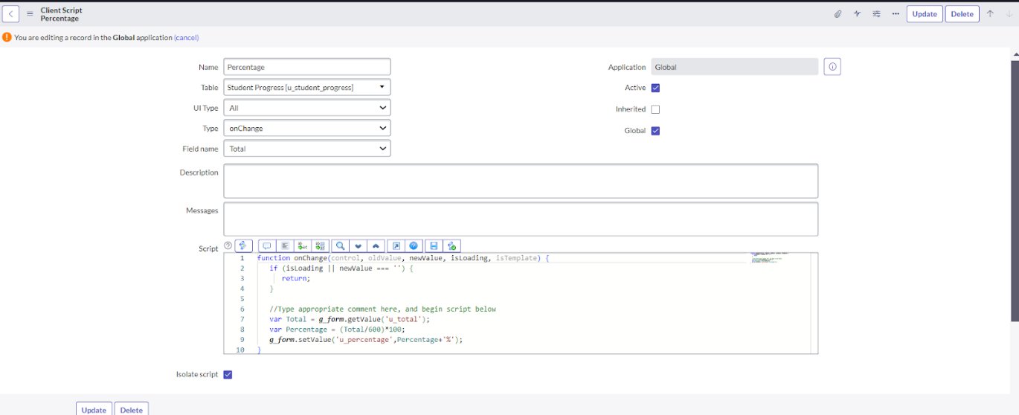

* Write the Code as below, Enable Isolate script and Save.

*function onChange(control, oldValue, newValue, isLoading, isTemplate) {*

*if (isLoading || newValue === '') {*

*return;*

*}*

*//Type appropriate comment here, and begin script below*

*var Total = g_form.getValue('u_total');*

*var Percentage = (Total/600)*100;*

*g_form.setValue('u_percentage',Percentage+'%');*

*}*

**Result**

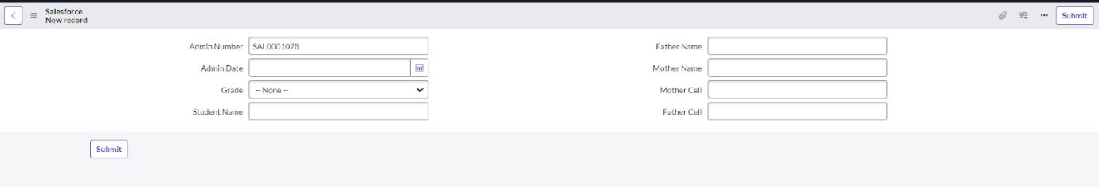

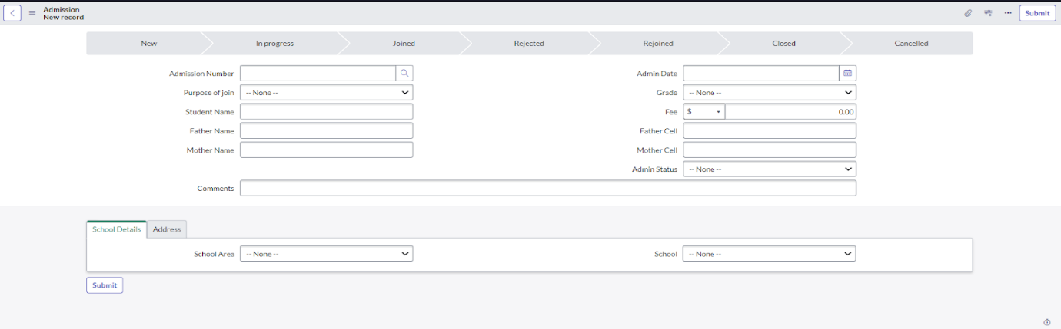

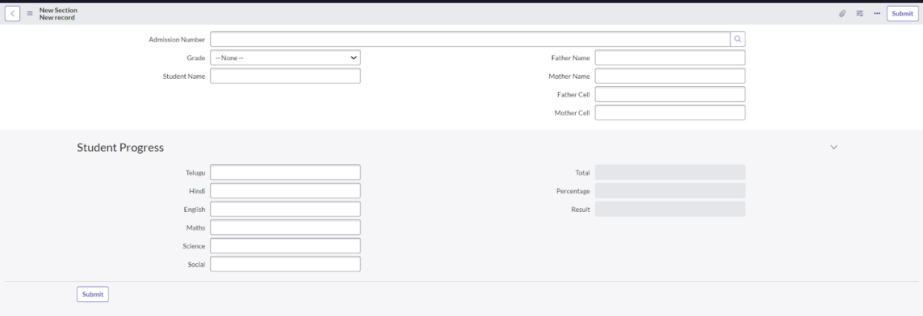

**THANK YOU**

**Team :**

**Team Id: NM2025TMID16149**

**Team Leader: DIVYASRI V**

**Team Member 1: GOPIKA A**

**Team Member 2: HARINI R**

**Team Member 3: VINDHYA A**